Table of Contents

Abstract | ……………………………………………………... | 1
1. Introduction
Background | ……………………………………………………... | 2
Previous Solutions | ……………………………………………………... | 2
Design Advantages | ……………………………………………………... | 3
Possible Applications | ……………………………………………………... | 4
2. Detailed Specification | ……………………………………………………... | 5
3. Design
Zeus | ……………………………………………………... | 7
Poseidon | ……………………………………………………... | 10
Athena | ……………………………………………………... | 13
4. Work Plan | ……………………………………………………... | 15
5. Cost Analysis | ……………………………………………………... | 17
References | ……………………………………………………... | 18
Abstract

We present a functional and portable version of an important new medical technique. There are several factors as to why we have chosen this as our project. We would like to provide to the medical world a tool which is relatively inexpensive and will open a whole new world of research possibilities to further the search for a cure and/or cause of current terminal blood related illnesses. This is not limited to diseases of the blood, but also encompasses tumors, strokes and much more. We have taken a previously built prototype as our initial guide, but we have taken inspirational engineering and the desire for simplification and created a new design. In order to facilitate in the construction of our product, we have broken it down into three essential parts. These parts have then been distributed to the group members with the most knowledge and expertise in the related fields. We will be able to stay within our budget by having the most expensive parts loaned to us for the scope of this project.
1. Introduction

Many modern day medical breakthroughs were made possible by analyzing data obtained in diverse environments. Our proposed product will give doctors another tool to bring their research into the more everyday lives of the patients. Our products will be a lightweight version of a new medical technique called Diffuse Optical Tomography.

Diffuse Optical Tomography (DOT) simultaneously detects the concentration of oxyhemoglobin, as well as the concentration of de-oxyhemoglobin. Laser sources transmit energy at specific wavelengths through a selected area of tissue. Once in the tissue, the energies are either absorbed or scattered back out of the tissue. It is this scatter-back that is monitored to detect changes in the hemoglobin levels as well as changes in the blood concentration. The changes in blood concentration effect the interpretation of the changes in oxyhemoglobin and de-oxyhemoglobin, especially in the brain.

We considered two imaging techniques prior to formulating our design methods. One technique is magnitude, which measures the optical flux entering the tissue.
The other technique is phasing, which appends the average propagation delay to the magnitude technique. By using the phase technique, we can get more information about the selected area of tissue, such as determining the density of a tumor or other abnormalities within the tissue. In keeping with our “light” concept, we intend on using the magnitude technique.

There are many other methods which also detect oxyhemoglobin and de-oxyhemoglobin. One such method uses electro-magnetic theory. In order to obtain the data, the subject is surrounded by a magnetic flux. Although this method does work, it is not recommended because of the hazardous impact it creates in the environment and the subject.

Another method in current use is Magnetic Resonance Imaging (MRI). This method is similar to an x-ray, except that the subject is scanned throughout the body. This process, although effective and safe, is very time consuming in acquiring and analyzing data. In medical situations, time is critical, so we would prefer to obtain the data in real-time. This will allow medical personnel to act immediately and make any needed modifications to the patient, as opposed to waiting for the data to be acquired and then processed before being able to act.

One of the newest methods available uses spectroscopy to gather data. This method has a few key advantages over the above mentioned methods. First, the process is flexible. It can be customized and adjustments made for various detection settings so that the most information can be received. This will benefit the end user, since he or she will be aware of the subject at hand and be able to make the proper changes.

Secondly, our design will be portable. Our product will be small which will allow for it to be used in a variety of ways. This will allow data collection to be done in various environments, without being restrained by the size of the tool. Also, the product will be light enough for the subject to carry it while active, i.e. jogging, and thereby making the concept versatile.

Finally, our product will allow the subjects to be examined repetitively. In doing so, we eliminate the possibility of missing crucial data due to the time consumption of MRI data acquisition and analysis.

We anticipate the cost of the components to be fairly inexpensive. Most of the components that will perform the data processing do not cost much to fabricate. The exception to our cost anticipations will be the laser diodes we intend to use, which will be donated. This is to our advantage, because we can focus on the functionality of our product without having to overexert our budget.

This method is an invaluable research tool. It is good to know how hemoglobin levels change in a controlled environment, but it is also essential to know what happens in a real environment. There are many variables that cannot be accurately simulated in a controlled environment that may affect the research. For example, when a person jogs on real ground, they are subject to chemical changes and to the environment around them. These two variables could hinder, cause or even cure certain maladies. Using other methods restricts the subject to a stationary position that isn’t ideal and practical. Also, in brain activity, mental factors also come into play. Any changes in mental conditions can cause changes in activity as well as in the levels of oxyhemoglobin and de-oxyhemoglobin in the bloodstream.

Our design has the professional in mind. We want to provide a useful tool that will help those perform not a better analysis, but a more effective one. We would like for them to get a current update, so that they can make any necessary alteration to give the most effective diagnosis to the subject under investigation.

One of our focuses for this design is the hemodynamic response in the blood. This is an increase in the concentration of oxyhemoglobin versus the decrease in the concentration of de-oxyhemoglobin. This is important because the ratio can help determine some solutions so that it is ideal to the professional who monitors it. We intend to look for this value when we perform our own analysis.

A second focus that we have is the rate of reduction of de-oxyhemoglobin in the blood. There are two factors that cause this to occur. One is the cerebral blood flow in the brain, while the other is the cerebral metabolic rate. These two factors are rationalized to determine the rate of reduction. If the ratio is high, then the rate of reduction increases. The increase can be primarily due to the increase of cerebral blood flow, but the metabolic rate can also be held accountable if the blood flow rate is low.

Currently, there is no apparatus on the market that has the functionally of our design along with the portability. We intend to incorporate portability with our apparatus, thus making it a more powerful tool. This tool can be used in a variety of ways. DOT has already been proven effective in detecting breast cancer in women. The current in use method of detection is x-ray mammography. However, there are studies that show a mammogram can increase the likelihood of getting cancer. Furthermore, it is also a time consuming process, unlike our design.

Our design can also be effective in treating encephalopathic patients, especially those suffering from a coma. Our design will allow adjustments to the patients to be in real time, and this is important because these patients are in critical condition, and time is of essence to them. Stroke patients can be analyzed with this tool, especially when the tragedy occurs. Since it is nearly an instantaneous process, a doctor can make adjustments immediately so that the subject will leave the current state.

Also, we can have a more accurate description of the pH level in the bloodstream. By having real time data, we can make more accurate predictions of the acidic levels in the bloodstream, and have a better gauge of detecting any major changes that can affect a user’s stability.

Finally, the process is less expensive than obtaining an MRI. This can narrow down the pool of patients who get sent to MRIs, and thereby eliminating the need for unnecessary MRI referrals, a big time and money saver. It will also allow more patients who can ill afford the cost of an MRI to first be seen using this less expensive product. For many, time is very crucial, and our design will help professionals spend it well.
2. Detailed Specification

The Advanced Portable Laser Unit Spectrograph (A-PLUS) has three separate sections: Zeus, Poseidon, and Athena. Zeus is the laser housing unit, Poseidon is the data processing unit, and Athena is the data storage and manipulation unit. Figure 2.1 shows an overview of our product.

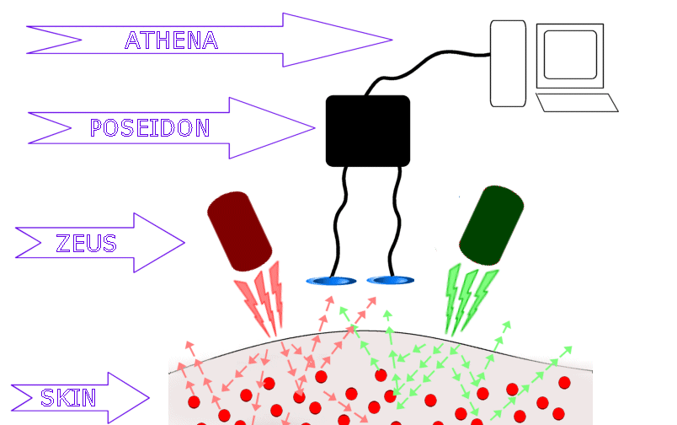
figure 2.1
Product overview

Zeus has two alternating lasers, operating at specifically chosen frequencies, which are fired into the skin/tissue. The frequencies chosen exploit the isobetic point of hemoglobin. The isobetic point is the frequency at which both the oxyhemoglobin and de-oxyhemoglobin have an identical absorption, as shown in figure 2.2. The frequencies will straddle this isobetic point and allow us to measure the hemoglobin concentration in the blood tissue.
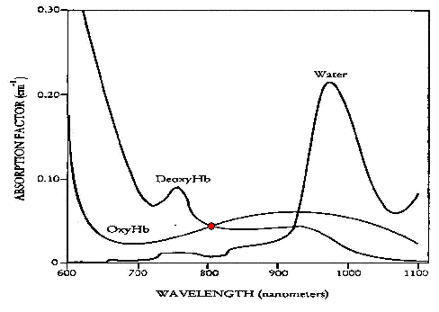
figure 2.2
Absorption factor vs. Wavelength [4]

The signal which the Poseidon unit will be receiving is the scatter back. The scatter back is the remainder of the laser energies that were not absorbed and was returned back through the skin. The photo-detectors have been strategically placed to give us more information about the scatter back. This is explained in more detail later. Poseidon will then clean up the signal it receives and extract from it a usable quantity which is passed on to Athena for storage and data recovery. Poseidon achieves this by employing a variety of filters and other signal processing component. Athena will store the signal on the flash card, or if the user chooses, direct the data to a connected computer via USB. The rest of Athena is a software package which will take the data and put it in a more readable format for the user.

The Zeus unit will be approximately 3”x2”x3”. The Poseidon unit will be approximately the size of a walkman and can be easily strapped to the waist. The Zeus unit will be constructed of a heat resistant material, possibly ceramic, to protect the user and the lasers.
3. Design

  - Zeus

The concept of the laser mounting and reception unit has undergone a great deal of iterative re-designing. As different methods for gathering data and unit operation were considered, the laser mounting and reception unit changed to accommodate these different ideas. One of our original designs called for an extensive use of optics. The current version of the unit has been substantially simplified from the original. Instead of using optics, a modulation technique is being applied. By modulating the laser light before it is introduced into the human tissue and then factoring out the modulation during signal processing, a useful signal can be collected without complex optical requirements.

Due to fundamental changes in the methodology of obtaining a reference signal, the Zeus unit no longer incorporates any reflective optics. As well, additional changes have been given to the basic form of the mounting itself. The basic configuration now incorporates two laser diode units, and two photo-detector diodes instead of the original four. Optical filters have been removed, as the photodiodes now function to detect both laser wavelengths. The new placement orientation for these components is illustrated below in figure 3.1.1.

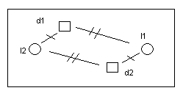
Figure 3.1.1
Top-down view of the laser/detector arrangement on mounting.
Lasers – l1, l2 Detectors - d1, d2

FUNCTIONALITY

The functionality of the Zeus unit has been simplified considerably. In the original design, a reference signal is obtained by separating the laser beam prior to entering the tissue. Instead, a new approach of modulating the laser signals and then factoring out the modulation during the signal processing stage is being applied. This technique allows for the reduction of the required photo detectors from four to two, which also reduces the number of wires running to and from the unit. Use of the modulation technique has also required a change in the function of the detectors.

Unlike previous designs where each laser had a detector filtered to its specific frequency, in the current model the remaining photodiodes are unfiltered and sensitive to both laser frequencies. The lasers alternate operation at 20 MHz intervals. During this time the diodes, spaced as illustrated above in Figure One, collect photon scatter. The lasers, signals, and processing are controlled by the main unit, and are detailed elsewhere.

MOUNTING UNIT

The mounting block has in large part remained unchanged. It is a rectangular solid unit, composed of a heat-resistant substance such as ceramic or composite. Heat resistance is required not only for protection of the patient from the components, but the components from the patients own body heat. The unit’s structure includes a slight body-conforming concavity to facilitate contact with the skin. An addition has also been made by way of a new means of attaching the unit to the body. Using solid linked units, such as on a metal watchband, the mounting can be held securely without fear of slipping or “floating” across the body to the same degree as had previous units. This is illustrated in figure 3.1.2.

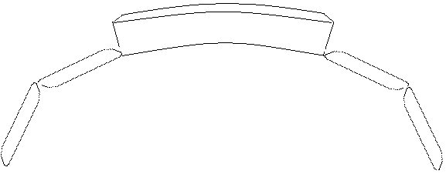
Figure 3.1.2
Zeus side view including band segments.

ZEUS EVOLUTION

The original design, or alpha version, of Zeus incorporated the extensive use of reflective optics and filtering. Two separate laser beams, of differing frequencies, were merged into a single beam. This beam was then put through a series of splitters on its way to the skin, where reference signals for each laser were specifically filtered out. After contact with the skin, the scattered laser light would be channeled back through the splitters and reflected to a different set of filters, which would detect the scatter signal. While a fascinating concept in theory, further research quickly illustrated the failings of this design.

Upon further research and investigation, we came to the conclusion that the amount of signal lost before contact with the skin was too great. This signal loss would propagate through the unit and the amount of useable signal collected is negligible. Another drawback found is placing the laser detector effectively over the laser incident point allowed for too great an interference from pure reflection as opposed to penetration and scatter signal.

Our second design, Beta, is a modification of the optical-splitting technique used in the Alpha design. Beta incorporated the splitting and referencing of the laser beams in Zeus, but instead used optically-filtered photodetectors directly in contact with the skin to measure the scattered light. There were a few orientations that were discussed for Beta and they can be seen in the figure below (figure 3.1.3).
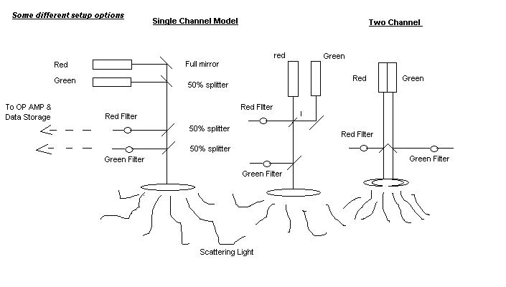
Figure 3.1.3
Various attempted orientations of Zeus Beta design’s laser emission and reference splitting optics

Much time was spent perfecting the form and function of this design. It was felt at the time that this would be the ideal model for the project. However, as with all ideal models, physical practice showed there to be a flaw.

As a beam of light travels, it begins to spread and scatter out in a cone-like fashion. Passing through, or being reflected by, a beam splitter exacerbates this effect, show with exaggeration below in figure 3.1.4

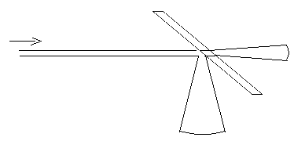

Figure 4
Illustraion of Laser spreading effect due to splitting/reflection.

After consulting with Prof. Charles DiMarzio of CenSSIS, it was decided that this spreading effect reduced the penetration of the actual beam to too great a degree. It also effectively illustrated that we could not incorporate reflective optics in our final design: to do so would require expensive lenses to re-focus the beam which is beyond our budget.

The revelations of Beta required a major redesign. The theme up until this point was to split the laser and gain reference signal through optics. This no longer being possible under project constraints, we considered many other methods and finally settled on Gamma, our current model.

  - Poseidon

The development of the data retrieval and decoder board has also gone through several redesigns with the developments with the laser sensor unit. Our first idea was to use the original design that was proposed by the previous team but after further examination of the board it was decided that we would redesign and simplify it. Our first design was based on the first design of Zeus, which had two lasers that are constantly on, and four sensors two for each laser wavelength, one for the reference and the other for the scatter back measurement. This idea used optical filters which allowed us to eliminate the band pass filters and in turn reducing the complexity of the board design. After learning that the Zeus-Alpha design was unfeasible on our budget we had to redesign the board to accommodate two lasers and two sensors as well as add additionally circuitry to oscillate the lasers, noise filtering and amplitude filtering.
Our first design was to use the original idea that was proposed by the previous team that started the project. Their board was designed to use only one receiver and the two lasers that oscillated. There was a Xilinx chip that was being used as the A/D converter and as a rough data analyzer for the data. The data is then stored in a removable flash memory card. A 20 MHz oscillation was used for the lasers and the data from the photo-detector was passed through a noise filter system consisting of a three-stage band pass filter. A schematic of the noise filter used is shown below in figure 3.2.1.

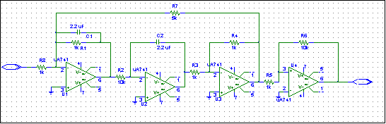
figure 3.2.1
Noise filter used in previous design.

Our second design was based on the alpha design of Zeus. By using the reference and optical filters we eliminated the need for band pass filters. We now have a design which requires simple noise filters and signal amplifiers. The Zeus-alpha design has four receivers, each of which passed data to the board. A series of multiplexors were then used to select which signal was passed through a 12 bit A/D converter. The digital signal which results is then passed on to the timestamp chip, which plays a dual role. It firsts adds a time stamp to the data and then also provides a temporary storage register so that the data cold be written into memory as a complete 32 bit word.

Our third and current design follows the changes made in Zeus. Zeus now uses only two photo-detectors and requires oscillating lasers. Figure 3.2.2 shows a block diagram of the new design.

Detector
Oscillator
Multiplier
OUTPUT
TISSUE
LASER
DC
LOW PASS
FILTER

figure 3.2.2
Block diagram of current Poseidon design

In order to maintain a usable reference signal, the oscillation used on the lasers is multiplied with the signal received from the detector in order to isolate the amplitude change. This is done using a simple trigonometric identity:
$$(A\text{cos}ωt)\text{cos}ωt=A\left(\frac{1}{2}+\frac{1}{2}\text{cos}ωt\right)$$
The low pass filter that follows the multiplier will eliminate the $\left(\frac{1}{2}\right)\text{cos}ωt$ factor, leaving a $\left(\frac{1}{2}\right)A$, which we can use.

By eliminating the optical filters we now need to introduce better band pass filters for each laser wavelengths and noise filtering for both wavelengths. The number of A/D converters has been increased to two so that the signals from each receiver can be measured at the same point in time to reduce the number of unknown variables. However, by increasing the number of A/D’s we also need to increase the number of filters. Each sensor now needs two sets of filters. Each set of filters consist of one filter for each laser wavelength. After the low pass filter described above, the data is then sent through a 2x1 multiplexor and then sent into a 12 Bit A/D converter. The same sequence of filters and multipliers is mirrored for the other sensor as well and the two 12 bit data signals are then sent into the time-stamp chip.
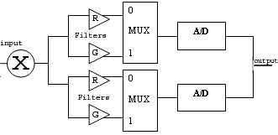
figure 3.2.3
Block diagram of multiplexing.

3.3 Athena

The last unit of our design is the Athena unit. Since the main purpose of this unit is to store and manipulate the final data, it has gone through the least amount of changes. Athena’s on board components are fairly simple. It consists of the Dallas time-stamp chip, a memory controller, and a removable 1GB flash card. After the data has been processed, it is passed to the time-stamp chip where it resides until a full 32bit word has been created. Figure 3.3.1 shows the breakdown of the 32bit word.

12bit Reference Data | 12bit Received Data | 1bit Laser Code | 7bit Time Stamp
Figure 3.3.1
32bit word breakdown

A memory controller has been added to increase the versatility of our product. This will allow the user to select from storing the data on the provided flash card or to link the unit to a computer, which will allow for immediate data analyzing. Figure 3.3.2 shows a basic block diagram of this design.
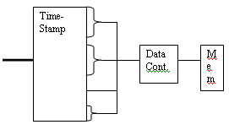
figure 3.3.2
Block diagram of Athena

Athena also consists of a software package we plan to code. This software package will use Matlab to analyze the data and provide an easy to interpret graph of the data. It will also format the data from the 32bit word into a more readable report. We will be using C++ to code the package as it integrates smoothly with Matlab and provides many GUIs.

4. Work Plan

The process of designing the A-plus unit is in its final stages. The group feels that we have come up with a design that will work. The purchasing, constructing, simulating, and testing process has yet to begin. Eric will do the purchasing of all the components in January. We simply need to decide on which company and brand we want to buy from. We have a list of components to choose from already. We feel that we will be able to finish constructing the three units be the end of winter quarter.

Zeus consists of many components: two lasers, which will be donated by Professor Chuck Dimarzio, one photo sensor, a low-pass filter, and a multiplier. We will need to build a mount for the lasers and the photo sensor. This step will require the work of Eric, Tam, and Timon. Tam believes that he has the tools necessary to build the mount for the lasers and photo sensors. Eric and Timon will design exactly how this piece of material should be shaped. The three of them will work together to bring this mounting unit to the precise weight required. This will be done in the second week of February. Mounting the lasers, photo sensor, low-pass filter, and multiplier is fairly simple. The only obstacle will be lining everything up exactly, and making sure all the components stay in their mounted position. Timon will be in charge of testing Zeus. He will run all necessary test and simulations. This will be done by the third week of February.

Poseidon and Athena can be treated as one unit during construction because they will both be stored in the same small unit. We imagine the unit to store Poseidon and Athena will look similar that of a walk-man. Finding or building the storage box is very simple. This will take a few days to find or make, and Tam will handle this project. Eric, Jason, Sophia, and Tam will all help simulate Poseidon and Athena. Eric, Jason, and Tam will mount, solder, and connect components to the proto board of Poseidon and Athena. Eric and Jason will simulate the boards to test Poseidon and Athena. This will all be done by the first week of March. All debugging and testing will be done in the month of February and March.

During this time Sophia will be working more with Athena, as she will be writing the software interfaces. She will need to take the data in memory on the flash card and display it to the user on the computer. Sophia will not be able to run this type of test until most of the unit is complete. We are predicting that the unit will be done by the beginning of May. By then Sophia will have the first Beta version of her software. We will be able to run the first test in the third week of April. Sophia will perform any further debugging of the software. We hope the final Beta will completed by the first week of May.

The power supply for the entire unit has been research by Tam. The full and final specs on the power needed are yet to be determined. We will know the exact voltage in the third week of March. This is where we will be able to determine the voltage needed to run the unit. Once this is determined, Tam will choose from the list of power supplies that is already done. We are hoping that one of the batteries on the list will be a perfect match for A-Plus. The power supply will be ordered by the end of March.
5. Cost Analysis

The estimated prototype costs as of yet are shown below in the Table 5.1. Important points to note:
- Lasers will be loaned to us from Professor DiMarzio’s lab
- 1 GB Flash card will be donated.

Item | Quantity | Estimated Cost Per Unit | Brand / Item Number | Total Cost
A/D Converters | 2 | $13.14 | Texas Instruments - THS1215IPW | $26.28
Test Boards | 6 | $25.00 | MicroEngineering Labs, Inc., ND PP80 | $150.00
Various Res/Caps | N/A | $100.00 | Radio Shack / Equipment Room | $100.00
Cabling | N/A | $65.00 | General Cable, Flexguard | $65.00
Flash Card | 1 | $499.99 | SanDisk 1.0GB CompactFlash Card | $499.99
Pulse Width Modulator | 20 | $0.99 | Texas Instruments UC3526 | $19.80
Photodiodes | 2 | $35.71 | TI (Burr-Brown) OPT301 | $71.42
Laser Diodes | 2 | $600.00 | Estimated Value Per laser | $1,200.00
Zeus Milling Cost | 1 | $100.00 | Need to find Vendor | $100.00
Total Cost If group purchased all parts, Some will be Donated for us |  |  |  | $2,232.49
Estimated Bulk Price of Unit |  |  |  | $1,500.00 to $1,700.00
Table 5.1

Zeus milling cost entails the non-conductive, lightweight, composite material that will be fabricated into a housing unit for both the lasers and photodiodes. We estimated $100 for the fabrication and purchasing of the material. Since this project is a continuation of a previously designed prototype, our prototype costs are reduced because we will be re-using components from the original prototype.

Distribution & Packaging

We estimate the distribution costs for our product will be between $1,500 - $1,700. These costs are drastically reduced from our prototype cause due to the fact that the components will be purchased in bulk. The costs of the more expensive components, such as the laser and photo diodes, are reduced by almost 30%. As of yet, we have not finalized our design and therefore these costs are only approximate.
References

[1] Chance B, Ntziachristos V, Schnall M, Yodh A, “MRI-Guided Diffuse Optical Spectroscopy of Malignant and Benign Breast Lesions”, “Neoplasis, no.4, July-August 2002, pp.347-354.

[2] Choi J, Gratton E, Michalos A, Paunescu A, Toronov V, Wolf M, Wolf U, “Different time evolution of oxyhemoglobin and deoxyhemoglobin concentration changes in the visual and motor cortices during funcational stimulation: a near-infared spectroscopy study”, “Neuroimage, vol.16 (3 Pt1), July 2002, pp.704-712.

[3] Schroeter M, Kruggel F, Kupka T, Von Y, Zysset S, “Near-Infrared Spectroscopy Can Detect Brain Activity During a Color-Word Matching Stroop Task in an Event-Related Design”, Human Brain Mapping, no.17, September 2002, pp.61-71.

[4] Arjun Yodh and B. Chance, “Spectroscopy and Imaging with Diffusing Light”, Physics Today, March (1995).

[5] Boas, Brooks, Miller, DiMarzio, Kilmer, Gaudette, Zhang, “Imaging the Body with Diffuse Optical Tomography,” IEEE Signal Processing Magazine, pp. 57 – 75, Nov. 2001.

[6] Laird, Cleary, Magnan, Moody, “Portable Optical Imager for Muscle Function” Spring 2002

