I. INTRODUCTION / BACKGROUND:

Autism is a complex developmental disability that typically appears during the first three years of life. The result of a neurological disorder that affects the functioning of the brain, autism impacts the normal development of the brain in the areas of social interaction and communication skills. Children and adults with autism typically have difficulties in verbal and non-verbal communication, social interactions, and leisure or play activities.

Autism is the most common of the Pervasive Developmental Disorders (PDD), affecting an estimated 2 to 6 per 1,000 individuals [1]. This means that as many as 1.5 million Americans today are believed to have some form of autism.

And that number is on the rise. Based on statistics from the U.S. Department of Education and other governmental agencies, autism is growing at a rate of 10-17 percent per year. At these rates, the ASA (American Society of Autism) estimates that the prevalence of autism could reach 4 million Americans in the next decade [2].

Teachers and parents who deal with autistic children know how frustrating it is to communicate with them, and many companies have set out with a mission to reduce this frustration. The Great Talking Box Company is the leading manufacturer of communication devices for autistic children and adults. Their products fit the cognitive needs of verbally impaired individuals. The latest product released is the e-talk CS 8400.

The dynamic screen software facilitates the creation of communication screens that flow from one to another allowing smooth creation of verbal communication. Pictures can be mixed with text and systems can be created ranging from completely picture based to completely text based or any combination in between. Other options included in the product are text-to-speech and digitally recorded speech of approximately 32 minutes [3]. | 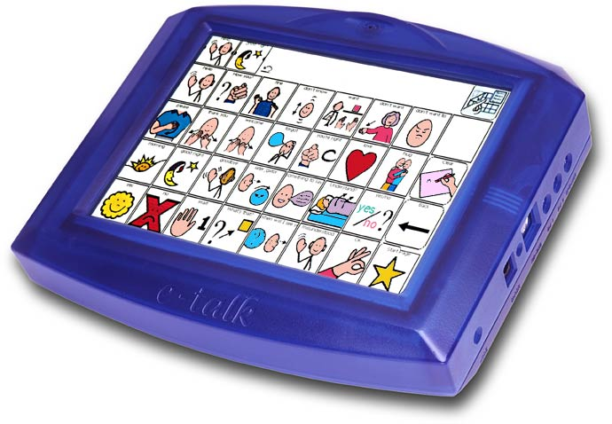  Figure 1 - E- Talk CS 8400

The price of the e-talk CS 8400 is roughly $4600. The cost of the lower-end version (CS5500) of these talking products is around $2000. Table 1 describes the specifications of different versions of E-talk [3].

CS8400 CS6400 CS5500
Display: 8.4" LTPS 6.5" color LCD 5.5" transflective monochrome
Resolution: 800 x 600 640x480 480x320
Size: 9" x 8" x 1.5" 8.75" x 7.75" 7.25" x 6.25"
Weight: 3.5 lbs 3.4 lbs 2.2 lbs.
Battery: Rechargeable Lithiu-
Charger: 12 V, 2.5A

Table 1: Specifications For E-Talk

It is the complexity of the hardware and software that make these devices expensive. One possible solution to minimize cost of speech devices is to scale down the complexity of the device. Consumers can integrate their already owned Palm OS handheld with our proposed software. The PC will retain compressed wave files, which will then be transferred to the PDA. This allows for more versatility and is cost effective. The cost of programming a PDA is a fraction of the existing products offered by The Great Talking Box Company.

It is the purpose of this Capstone project to create the software that can be used with a PDA to simulate a scaled down talking device for autistic children and young adults.

II. DESIGN PROJECT:

The design of the project will include three parts: the Palm software, PC software and the conduit:

Palm Software

a) User Interface Specifications:
The user interface is the first component that comprises the Palm software. The User interface displays icons, which have different categories. The icons link to different screens when selected. Each icon maps to different words and phrases. The menus are two levels deep. The first level is the main menu which has nine icons. Refer to Table 2 for a list of categories.

As can be seen in the Figure 2 labeled User Interface Design, the user interface for the software incorporates colorful, easy to recognize icons (coupled with text) which are selected using the above mentioned techniques.

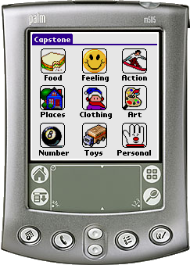

Figure 2: User Interface

Each icon in the main menu has its own windows. When the icon in the main menu is selected, it opens a new window called the Sub-menu (See Figure 4). There are two options for the user to choose in each sub-menu: the “Lead-in” words option and “List of Items” options. Each category will have its own “Lead-in” words. For example, under the “Food” category, the “Lead-in” option would include “I want”, “I need”, and “I have”. Under the “Places” category, the list of “lead-in” words would include “I want to go”, “I want to go to” and “I want to go to the” after which the desired place would be chosen by the user. The “List of Items” is the place where user chooses items he/she wants. For instance, in the sub-menu Food, the “List of Items” would be: bread, milk, meat, rice, soup, etc. Under the sub-menu Places the “List of Items” would be house, school, park, stadium, etc.

We want to make the list of items short, so the user does not have to spend time to search through the list. Therefore, by default, there will be about twenty items in each list, but the user can add or delete items in “List of Items” to his/her desire. There are some examples of the “Lead-in Word” and “List of Items” of each category shown in Table 2 below.

Table 2: Example of Lead-in Word and List of Items

Categories | Lead-in Words | List of Items
Food | I want, I have, I need | Bread, Eggs, Fruit…
Feeling | I am, I feel… | Sad, Happy, Angry…
Action | I want, I have, I need… | Run, Walk, Jump…
Places | I want to go, I want to go to | Library, School, Park…
Clothing | I want, I have, I need… | Shirt, Jeans, Hat…
Art | I want, I have, I need… | Paint, Paper, Pen…
Number | I am, I want, I need | One, Two, Three…
Toys | Let us play, | Cars, Airplane, Balloon…
Personal | Miscellaneous | Miscellaneous

Below the user selection option in sub-menu, there are three buttons: Play, Add and Menu. The Play button will play the phrase that the user has selected. The Add button will add more items in the waiting sentence. For example, when user wants milk and bread, first he/she checks the lead-in word “I want” and “List of Items” to select milk. Next, the user scrolls the list to find bread and then presses the Add button. The Menu button lets user choose items in different categories. In another case, the user may want a red car (toys). He/she would choose the color red in the Art category and then press the Menu button to go back to the Main menu where he/she would select the Toys category. In the toys category he/she can choose car and press the Play button. | 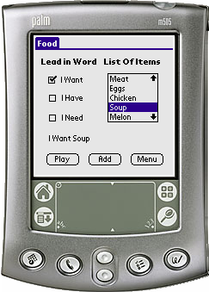  Figure 3: Sub-Menu

b) Database Specifications:
The second component of the Palm Software is the database. There are two different databases, one for Palm handheld, and the other is inside the user PC. The PDA has approximately 8 MB of memory. Each phase will be assigned to a certain part of memory. A pointer will point to the address of that memory when the user selects the phrase. The PC will contain files containing different words and phrases. Our aim will be approximately to have 100 words that can combine to form compound sentences. However, space and time may permit use of 1000 or more words. The files will be transferred to PDA by using a conduit to synchronize the data between the two.

c) Audio Driver Specifications:
The last element of the Palm software is the Audio driver. The software running on the Palm handheld device will output high-fidelity audio such that human speech is clearly audible and understandable. The Palm handheld device must be able to store at least 100 sentences worth of audio.
It is not necessary to add the capability to record speech directly into the Palm handheld device since the PC software will allow audio to be transferred to the Palm handheld device using Palm HotSync® software.

d) Audio Playback Design
Audio playback on the Palm handheld device will be accomplished using the built in support for sound playback in Palm OS 5. Both uncompressed linear PCM (Pulse Code Modulation) wav and compressed IMA ADPCM (Interactive Multimedia Association Adaptive Differential Pulse Code Modulation) wav formats are supported. The compressed wav format encodes 16-bit digital audio samples into 4 bits with little quality loss. Speech signals typically have a bandwidth of roughly 8 KHz, and therefore a sampling rate of 16 KHz is sufficient to encode them with little to no loss of high frequency information. This results in a final bit rate of 16 KHz * 4 bits = 64 Kbps = 8 KB/s. Assuming 8 megabytes of storage space on the handheld device specifically for audio data, this allows 1000 seconds of audio to be stored. The actual amount of space for audio is less than the total amount on the handheld device due to overhead from the Palm database format, the text labels, and the optional icons for each audio clip. Icon file sizes may vary from less than 1 KB to as high as 64 KB for a large 64 x 64 uncompressed, 16-bit color icon. 1000 seconds of audio allows approximately 2000 0.5-second words, approximately 333 3-second phrases, or some combination of the two.

e) Other Audio Compression Formats
We considered using higher levels of audio compression since an improved compression algorithm would offer increased amounts of audio storage. There are many reasons, however, not to implement such a solution. Greater complexity of the software would increase development time, and we have limited time in which to complete the software. This is offset by very little increased functionality, as we do not project insufficient storage space or audio fidelity of the IMA ADPCM wav format. Also, current Palm OS based handheld typically do not use software decoders, relying instead on hardware decoder chips which may vary among different device models and manufacturers, and are not supported directly by the Palm OS. The format is also burdened by licensing fees of $0.75 per unit [4]. Similar levels of compression are available with license free formats, for example Ogg Vorbis [5], and a fixed-point version of the decoder was recently released by Xiph.org [6]. Adding support for a compression algorithm such as Ogg Vorbis would be an optional feature, possibly to be added in a future version or in remaining time after all other development has been completed.

PC Software
Our software application consists of two databases. : One that resides on the palm and the other that resides on the PC. The database stores all the information associated with our software application such as sound files, text labels, menu headings. Inline with the philosophy of Palm we are restricting the large-scale data entry to the PC software. In terms of our software application that means that all modifications take place on the PC software. The modifications can be classified into 5 different areas namely, recording, conversion, categorizing, previewing and deleting.

Recording
Our software will make use of the existing recording applications available on the windows platform to enable the users to record their own sounds files. During the recording process the users is prompted to include a text label to be associated with the sound file.

Conversion
Once the user has recorded the sound file, our application in the background will convert this .wav file to the .pdb file format which is recognized by the Palm. How this actual conversion takes place is discussed in more details in the audio section.

Categorizing
The next step is for the user to place the newly recorded items in one of the nine standard categories. For example, if the new sound recorded is the word pineapple, the user could categorize this under the food menu.

Previewing
The PC software allows the user to preview their additions. The preview will simulate the actual operation that takes place on the palm.

Deleting
The user can delete their additions if not satisfied and rerecord their sound. The user can also delete the pre-defined words that came originally with the palm, if they choose to. The original template of the software application can be restored if the user inadvertently deletes files.

To get the new information onto the palm, the conduit is used. This is explained in the following section.

Conduit
The conduit is a program that synchronizes data between the PC and the handheld. It will transfer files from the PC into the PDA. The conduit works via HotSync Manager and Client. The HotSync manager oversees synchronization of a handheld on the desktop computer. HotSync Manager runs in the background on the user's computer and monitors one or more communication ports for the signal to begin synchronization [8]. When HotSync Manager receives that signal, HotSync Manager initiates the synchronization process and calls the conduits installed on the user's desktop computer.

The HotSync client is a built-in Palm OS application on the handheld that launches when a user presses the HotSync button on the cradle. The client signals HotSync Manager on the desktop computer. HotSync Manager communicates with the HotSync client to set up the properties of the synchronization operation. From the HotSync client, the user selects the connection type (local or modem) and its properties (direct serial, infrared, modem type, and so on) [8]. During a HotSync operation, the HotSync client responds to Sync Manager Request to access databases on the handheld.

Depending on the value of the back-up bit, the conduit can be used in two ways. The data on the PC can overwrite the handheld, or the handheld can overwrite the PC. For this palm application the mode of the conduit will be set to “PC Overwrites Handheld”. During synchronization between the PDA and PC, the files in the PC will be copied to the handheld. The basic working structure of the conduit and HotSync is shown below in Figure 4 labeled Conduit and HotSync Operation.

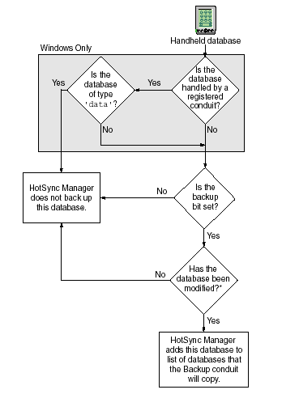

Figure 4: Conduit and HotSync Operation

III. COST ANALYSIS:

There are 3 components related to our cost analysis – namely development tools, cost of actual palm and distribution costs.

Development Tools:
The costs related to this project are limited due to the software development tools that PalmSource has made available to developers of the Palm OS software. These tools include a free simulator, emulator and SDKs(Software development kit) which contains the latest header files, libraries and tools for Palm OS development on Windows and Mac OS. PalmSource also supports a variety of development suites namely Metrowerks CodeWarrior and the free alternative GNU PRC-Tools. The CodeWarrior academic version costs $119. We have chosen to work initially with the GNU PRC-Tools due to the differences in the prices, but the trade-off with this choice is that the GNU PRC-Tools has a steeper learning curve for us since most of the team members have already worked with CodeWarrior. We are using the remainder of the year to familiarize ourselves with the GNU PRC-Tools, by the beginning of 2003 we will evaluate whether we should indeed forge ahead with our initial decision or purchase CodeWarrior.

Cost of Actual Palm:
Another dimension related to our cost is the use of an actual palm to test our software. Currently we have in our possession a palm running Palm OS 3. This palm was obtained from one of our members who already owned the palm. The only draw back with this palm is its limited audio capabilities. The palm is equipped with a simple piezoelectric speaker which is capable of generating only a single tone. Accurate voice playback would only be possible with additional hardware. A key component of our project is reliant on effective sound production. The only Palm OS version that has the audio capabilities we require built into it is version 5. This version is equipped to allow an application play complex recorded sounds, it supports 16-bit multi channel sound and has the ability to record and play CD-quality digital audio. Thus, to truly test the functionality of our product we will need to obtain a palm running Palm OS 5. We will not be able to update the operating system version because the superior sound capabilities of the new OS are based on new hardware, i.e. the ARM processor. The only palm that we have found that runs on Palm OS 5 is the Tungsten T which currently costs $499. We are not planning to purchase a palm running OS 5 until the final stages of our development, because we can still test and debug our program on the existing palm we have, and the simulator (which is essentially Palm OS 5). By April 2003, when we plan to purchase the palm, we project that the price of palms running OS 5 will have fallen to around $300.

Distribution Costs:
We have limited costs associated with the actual distribution of our software solution because we plan to have our software downloaded from the internet. The cost associated with this, would be the cost of hosting a website which costs about $4.95/month.

Overall Cost Estimate:
The costs associated with our project are depicted in the following table.

Table 3: Cost Analysis
 | Maximum Cost ($) | Minimum Cost ($)
Palm running OS 5 | 300.00 | 300.00
Web hosting (for a year @ 4.95/mo) | 59.40 | 59.40
CodeWarrior | 119.00 | -
Total Cost | 478.40 | 359.40

As shown above the maximum cost associated with our project is $479 (rounded up), if by the beginning of January 2003 we decide not to purchase CodeWarrior the cost of our project will then be $360 (rounded up).

IV. Limitations:
There are features not included in the Palm application. One feature is text-to-speech. In other words, the user will not be able to write messages on the PDA and then the words come out of the speaker. Another limitation is the words and phrases. The interface contains several basic words that can be combined to form simple sentences. Nevertheless, it will not be possible to form complex sentences.

Another consideration is what palm software version to use. Currently the software we are designing is limited to Palm OS version 5.0. In other words, the consumer must already own the PDA with that version software. The reason for using this version is explained in Cost Analysis. The users PDA must have also have speakers that are audible, and a PC to store the wave files.

V. Project Schedule:

In summary, our schedule for the winter quarter involves the planning and design of our software. Jay will work on the storage format specification. Khoa will write code to display icons and text on buttons to detect stylus clicks. Adaeze and Ynnesh will design and test the PC software GUI. Laura will write, compile and test the conduit to synchronize data between PC and the Palm. The spring quarter will consist of testing and debugging our code. Refer to Table 4 labeled Worked Schedule.

Table 4: Work Schedule

 | Week | Jay | Khoa | Adaeze | Ynnesh | Laura
 | 1 | Write storage format specification | Write code that displays color icons and text together on buttons that detect stylus clicks, code that can highlight a button | Refine feature list and design of PC software GUI, write and compile code with any simple GUI (e.g. button and list) |  | Write, compile, and test a simple conduit that writes a single file from the PC to the Palm device
Winter | 2
 | 3
 | 4
 | 5
 | 6 | Write code to stream multiple files with size >64K, write code to remap mechanical buttons |  | Write code that can convert uncompressed wav files, icons and text labels into a Palm database in our storage format, write test code for other major features depending on final feature list
 | 7
6-Jan | 8
 | 9
 | 10
Spring | 1 | Deadline for final Palm software feature list, integrate existing code |  | Begin integrating existing code |  | Deadline for final conduit conflict resolution spec, begin adding features to simple conduit
 | 2 | Continue programming |  | Continue programming |  | Continue programming
 | 3 | Deadline for final menu structure and wordlist, record final audio
 | 4 | Continue programming |  | Continue programming |  | Continue programming
1-May | 5 | Deadline for first version of all software
 | 6 | Testing of integration between Palm software, PC software, and conduit, debugging, leeway if deadline slips
 | 7
 | 8
 | 9
 | 10
 | 11
 | 12

References

Internet

[1] Center of Disease Control and Prevention, "FAQs About Autism", http://www.cdc.gov/nip/vacsafe/concerns/autism/autism.htm, (5 Dec. 2001).

[2] http://www.autism-society.org/site/

[3] http://www.greattalkingbox.com/

[4] http://licensing.com/royalty/index.html]

[5] www.vorbis.com

[6] http://www.xiph.org/ogg/vorbis/index.html

[7] Palm Source, “Developers” http://www.palmsource.com/ (December 7, 2002)

[8] http://www.palmos.com/dev/support/docs/conduits/

Books

K Jamsa, Palm OS Developer’s Guide, California, Brandon A. Nordin, 2002.

K Jamsa, Instant Palm OS Applications, California, Brandon A. Nordin, 2001.

