Higher education

Not what it used to be

American universities represent declining value for money to their students
Dec 1st 2012 | CHICAGO | from the print edition

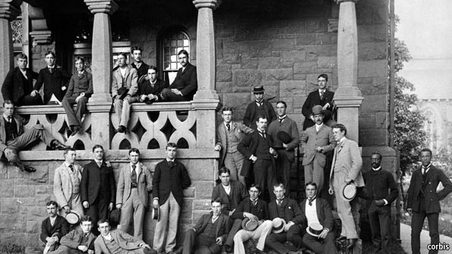Running the numbers
ON THE face of it, American higher education is still in rude health. In worldwide rankings more than half of the top 100 universities, and eight of the top ten, are American. The scientific output of American institutions is unparalleled. They produce most of the world’s Nobel laureates and scientific papers. Moreover college graduates, on average, still earn far more and receive better benefits than those who do not have a degree.
Nonetheless, there is growing anxiety in America about higher education. A degree has always been considered the key to a good job. But rising fees and increasing student debt, combined with shrinking financial and educational returns, are undermining at least the perception that university is a good investment.
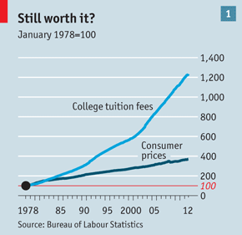
Concern springs from a number of things: steep rises in fees, increases in the levels of debt of both students and universities, and the declining quality of graduates. Start with the fees. The cost of university per student has risen by almost five times the rate of inflation since 1983 (see chart 1), making it less affordable and increasing the amount of debt a student must take on. Between 2001 and 2010 the cost of a university education soared from 23% of median annual earnings to 38%; in consequence, debt per student has doubled in the past 15 years. Two-thirds of graduates now take out loans. Those who earned bachelor’s degrees in 2011 graduated with an average of $26,000 in debt, according to the Project on Student Debt, a non-profit group.
More debt means more risk, and graduation is far from certain; the chances of an American student completing a four-year degree within six years stand at only around 57%. This is poor by international standards: Australia and Britain, for instance, both do much better.
At the same time, universities have been spending beyond their means. Many have taken on too much debt and have seen a decline in the health of their balance-sheets. Moreover, the securitisation of student loans led to a rush of unwise private lending. This, at least, has now been curbed by regulation. In 2008 private lenders disbursed $20 billion; last year they shelled out only $6 billion.
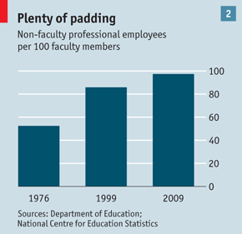
Despite so many fat years, universities have done little until recently to improve the courses they offer. University spending is driven by the need to compete in university league tables that tend to rank almost everything about a university except the (hard-to-measure) quality of the graduates it produces. Roger Geiger and Donald Heller of Pennsylvania State University say that since 1990, in both public and private colleges, expenditures on instruction have risen more slowly than in any other category of spending, even as student numbers have risen. Universities are, however, spending plenty more on administration and support services (see chart 2).
Universities cannot look to government to come to the rescue. States have already cut back dramatically on the amount of financial aid they give universities. Barack Obama has made it clear that he is unhappy about rising tuition fees, and threatens universities with aid cuts if they rise any further. Roger Brinner from the Parthenon Group, a consultancy, predicts that enrolment rates will stay flat for the next five to seven years even as the economy picks up. The party may be well and truly over.
Balloon debate
In 1962 one cent of every dollar spent in America went on higher education; today this figure has tripled. Yet despite spending a greater proportion of its GDP on universities than any other country, America has only the 15th-largest proportion of young people with a university education. Wherever the money is coming from, and however it is being spent, the root of the crisis in higher education (and the evidence that investment in universities may amount to a bubble) comes down to the fact that additional value has not been created to match this extra spending. Indeed, evidence from declines in the quality of students and graduates suggests that a degree may now mean less than it once did.
For example, a federal survey showed that the literacy of college-educated citizens declined between 1992 and 2003. Only a quarter were deemed proficient, defined as “using printed and written information to function in society, to achieve one’s goals and to develop one’s knowledge and potential”. Almost a third of students these days do not take any courses that involve more than 40 pages of reading over an entire term. Moreover, students are spending measurably less time studying and more on recreation. “Workload management”, however, is studied with enthusiasm—students share online tips about “blow off” classes (those which can be avoided with no damage to grades) and which teachers are the easiest-going.
Yet neither the lack of investment in teaching nor the deficit of attention appears to have had a negative impact on grades. A remarkable 43% of all grades at four-year universities are As, an increase of 28 percentage points since 1960. Grade point averages rose from about 2.52 in the 1950s to 3.11 in 2006.
At this point a sceptic could argue that none of this matters much, since students are paid a handsome premium for their degree and on the whole earn back their investment over a lifetime. While this is still broadly true, there are a number of important caveats. One is that it is easily possible to overspend on one’s education: just ask the hundreds of thousands of law graduates who have not found work as lawyers. And this premium is of little comfort to the 9.1% of borrowers who in 2011 had defaulted on their federal student loans within two years of graduating. There are 200 colleges and universities where the three-year default rate is 30% or more.
Another issue is that the salary gap between those with only a high-school diploma and those with a university degree is created by the plummeting value of the diploma, rather than by soaring graduate salaries. After adjusting for inflation, graduates earned no more in 2007 than they did in 1979. Young graduates facing a decline in earnings over the past decade (16% for women, 19% for men), and a lot more debt, are unlikely to feel particularly cheered by the argument that, over a lifetime, they would be even worse off without a degree than with one.
Moreover, the promise that an expensive degree at a traditional university will pay off rests on some questionable assumptions; for example, that no cheaper way of attaining this educational premium will emerge. Yet there is a tornado of change in education that might challenge this, either through technology or through attempts to improve the two-year community college degree and render it more economically valuable. Another assumption, which is proved wrong in the case of 40% of students, is that they will graduate at all. Indeed, nearly 30% of college students who took out loans eventually dropped out (up from 25% a decade ago). These students are saddled with a debt they have no realistic means of paying off.
Some argue that universities are clinging to a medieval concept of education in an age of mass enrolment. In a recent book, “Reinventing Higher Education”, Ben Wildavsky and his colleagues at the Kauffman Foundation, which focuses on entrepreneurship, add that there has been a failure to innovate. Declining productivity and stiff economic headwinds mean that change is coming in a trickle of online learning inside universities, and a rush of “massive open online courses” (MOOCs) outside them. Some universities see online learning as a way of continuing to grow while facing harsh budget cuts. The University of California borrowed $6.9m to do this in the midst of a budget crisis. In 2011 about 6m American students took at least one online course in the autumn term. Around 30% of all college students are learning online—up from less than 10% in 2002.
Digital dilemmas
To see how efficient higher education can be, look at the new online Western Governors University (WGU). Tuition costs less than $6,000 a year, compared with around $54,000 at Harvard. Students can study and take their exams when they want, not when the sabbaticals, holidays and scheduling of teaching staff allow. The average time to completion is just two-and-a-half years.
Running the numbers
MOOCs have also now arrived with great fanfare. These offer free college-level classes taught by renowned lecturers to all-comers. Two companies, Coursera and Udacity, and one non-profit enterprise, edX, are leading the charge. At some point these outfits will need to generate some revenue, probably through certification.
The broader significance of MOOCs is that they are part of a trend towards the unbundling of higher education. This will shake many institutions whose business model is based on a set fee for a four-year campus-based degree course. As online education spreads, universities will come under pressure to move to something more like a “buffet” arrangement, under which they will accept credits from each other—and from students who take courses at home or even at high school, spending much less time on campus. StraighterLine, a start-up based in Baltimore, is already selling courses that gain students credits for a few hundred dollars.
Some signs suggest that universities are facing up to their inefficiencies. Indiana University has just announced innovations aimed at lowering the cost and reducing the time it takes to earn a degree. More of this is needed. Universities owe it to the students who have racked up $1 trillion in debt, and to the graduate students who are taking second degrees because their first one was so worthless. They also bear some responsibility for the 17m who are overqualified for their jobs, and for the 3m unfilled positions for which skilled workers cannot be found. They even owe it to the 37m who went to college, dropped out and ended up with nothing: many left for economic reasons.
Universities may counter that the value of a degree cannot be reduced to a simple economic number. That, though, sounds increasingly cynical, when the main reason universities have been able to increase their revenue so much is because of loans given to students on the basis of what they are told they will one day earn.
from the print edition | United States

